Day 11 - 19th June 2025

Java 8 Features
👍

Streams
Lambda Exp

Functional Interfaces
Concrete methods….we can body of the methods
Default methods
Static methods
Collection API
Fork join methods
Method ref - class name :: method name
Comparable and comparators
Abstract and private methods
NIO

=====================

C++ – pure virtual functions

Void display() = 0;

=========================

Extends Class Name

Implement Interface Name

STreams —-- stream of data..

Task 1:

What are streams

Streams are like a continuous flow of data moving from one place to another, just like water flowing in a river. They allow data to be read or written efficiently without needing to load everything at once. In programming, streams help process large amounts of information smoothly, whether it’s reading a file, receiving network data, or handling user input. We can think of them as a pipeline that transports data bit by bit instead of dumping everything all at once.

Task 2:
Write about :

Boilerplate code:
It's like writing the same setup or structure again and again just to get something to work. Even if it doesn’t change much, we still have to type it every time. It feels like extra work with no real value.
Real-life example:— Like Filling Forms Repeatedly
Imagine every time you go to a new doctor, they ask you to fill the same basic form: name, age, contact, allergies.
Even though your information doesn’t change, you still have to write everything again and again.
In code:
That’s what boilerplate is — writing the same structure (like main() in Java) every time even if it doesn’t change or add logic. It's needed but repetitive.

Lack of parallelism: One Person Doing All Tasks One by One
When tasks or operations are done one by one, even if they could be done at the same time. It slows things down, especially when the system or program could handle multiple things together.
Real-life example:
Suppose you're cooking a meal.
You first cut vegetables, then boil water, then make tea, then set the table — all by yourself.
It takes a lot of time.
Better way (parallelism):
You start boiling water, and while it’s boiling, you cut vegetables. Meanwhile, someone else makes tea. Now, tasks finish faster.
In code:
Parallelism is like assigning tasks to multiple people (or threads), so everything happens faster.

Lack of Composition: — One Big Machine That Does Everything
When pieces of code are not flexible or reusable. We can’t easily take one part and use it somewhere else because everything is too tightly connected or written in a way that can’t be mixed with other parts.
Real-life example:
Imagine you buy a machine that can make coffee, toast bread, and wash dishes, but it only works if you use all 3 features together.
You can’t just use it to make coffee separately.
In code:
That's a lack of composition — the parts (features) are too tightly packed.
You can’t reuse or replace individual parts easily.
Better way:
Separate devices — a coffee maker, a toaster, and a dishwasher — so you can use only what you need, or combine them however you like.

Task 3:

List of Intermediate and terminal operations

list of Intermediate and Terminal operations in Java Streams API

Intermediate Operations
(These return a new stream and are lazy – they don’t do anything until a terminal operation is used.)
Operation | What it does
filter() | Selects elements based on a condition
map() | Transforms each element
flatMap() | Flattens nested structures
distinct() | Removes duplicates
sorted() | Sorts elements
peek() | Performs an action without changing the stream (for debugging)
limit(n) | Limits the stream to first n elements
skip(n) | Skips the first n elements
mapToInt() / mapToDouble() / mapToLong() | Converts stream to primitive types
boxed() | Converts primitives to wrapper objects

Terminal Operations
(These trigger processing and produce a result or a side-effect.)
Operation | What it does
forEach() | Performs an action for each element
collect() | Converts the stream to a collection (List, Set, Map, etc.)
toArray() | Converts stream to an array
reduce() | Combines elements to produce a single result
count() | Counts elements
anyMatch() | Checks if any element matches a condition
allMatch() | Checks if all elements match a condition
noneMatch() | Checks if no elements match a condition
findFirst() | Returns the first element (optional)
findAny() | Returns any element (useful in parallel)
min() / max() | Finds minimum/maximum using a comparator

======================================================================

Lambda Expressions
======================================================================

Task 4:

import java.lang.FunctionalInterface;

// this is functional interface
@FunctionalInterface
interface MyInterface{

// abstract method
double getPiValue();
}

public class Main {

public static void main( String[] args ) {

// declare a reference to MyInterface
MyInterface ref;

// lambda expression
ref = () -> 3.1415;

System.out.println("Value of Pi = " + ref.getPiValue());
}
}

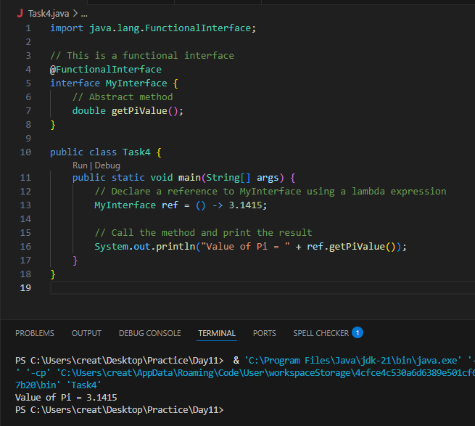

Task 5:

@FunctionalInterface
interface MyInterface {

// abstract method
String reverse(String n);
}

public class Main {

public static void main( String[] args ) {

// declare a reference to MyInterface
// assign a lambda expression to the reference
MyInterface ref = (str) -> {

String result = "";
for (int i = str.length()-1; i >= 0 ; i--)
result += str.charAt(i);
return result;
};

// call the method of the interface
System.out.println("Lambda reversed = " + ref.reverse("Lambda"));
}

}

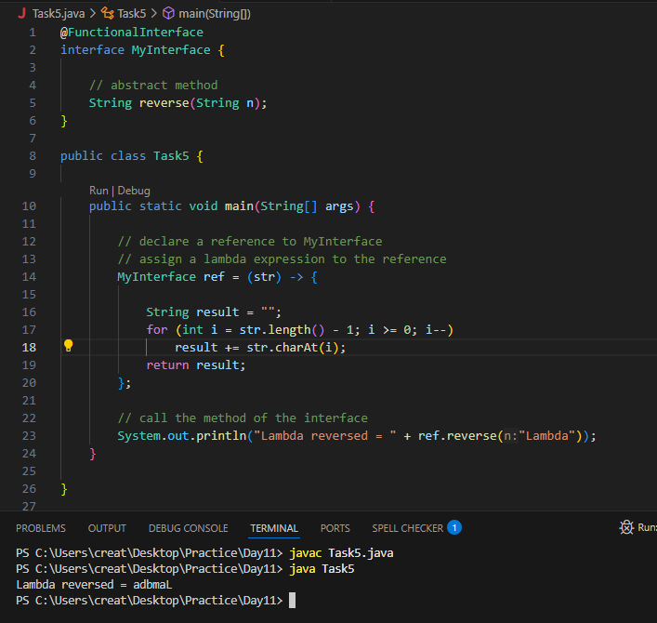

Task 6:

import java.util.ArrayList;
import java.util.List;

public class StreamMain {

// create an object of list using ArrayList
static List<String> places = new ArrayList<>();

// preparing our data
public static List getPlaces(){

// add places and country to the list
places.add("Nepal, Kathmandu");
places.add("Nepal, Pokhara");
places.add("India, Delhi");
places.add("USA, New York");
places.add("Africa, Nigeria");

return places;
}

public static void main( String[] args ) {

List<String> myPlaces = getPlaces();
System.out.println("Places from Nepal:");

// Filter places from Nepal
myPlaces.stream()
.filter((p) -> p.startsWith("Nepal"))
.map((p) -> p.toUpperCase())
.sorted()
.forEach((p) -> System.out.println(p));
}

}

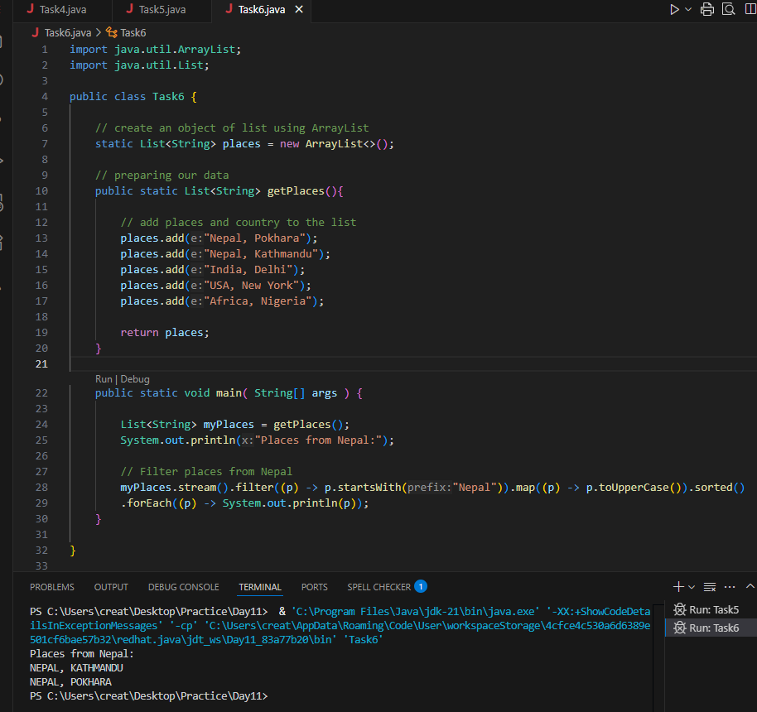

Task 7:

Write a code to create a array list to store 5 integers and display the square of each no..
*Hint:

List<Integer> squareofNums = numbers.stream().map(num->num*num).collect(Collectors.toList()
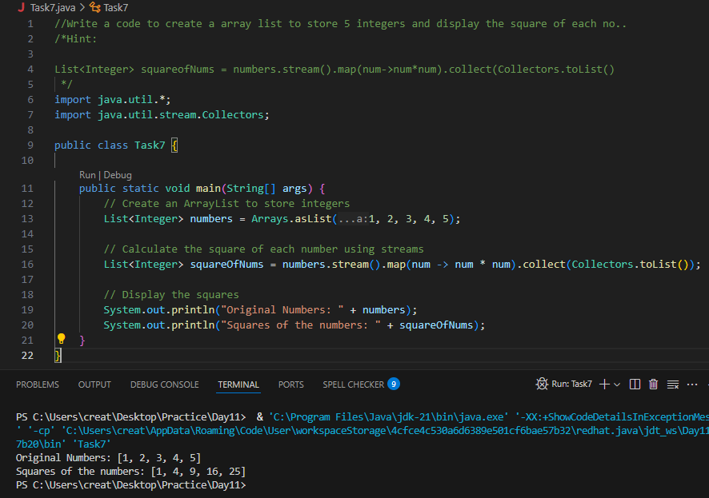
Task 8:
What do you understand by map()?

map() takes every item in a stream and transforms it—like saying, “Take each number and turn it into its square,” or “Take each name and make it uppercase.” It doesn’t remove or add anything—just changes each element into a new form, one by one.

It’s kind of like a filter in disguise—but instead of deciding which items stay, it decides how each item looks after transformation.

Think of it as a translator for our stream. we give it something, and it gives back a tweaked version of everything you passed in.

Task 9:

Write a code to create an array list and filter the values which are odd numbers and display them..

Hint:
List<Integer> addNumbers = numbers.stream()
.filter(num -> num % 2 !=0)
.collect(Collectors.toList());
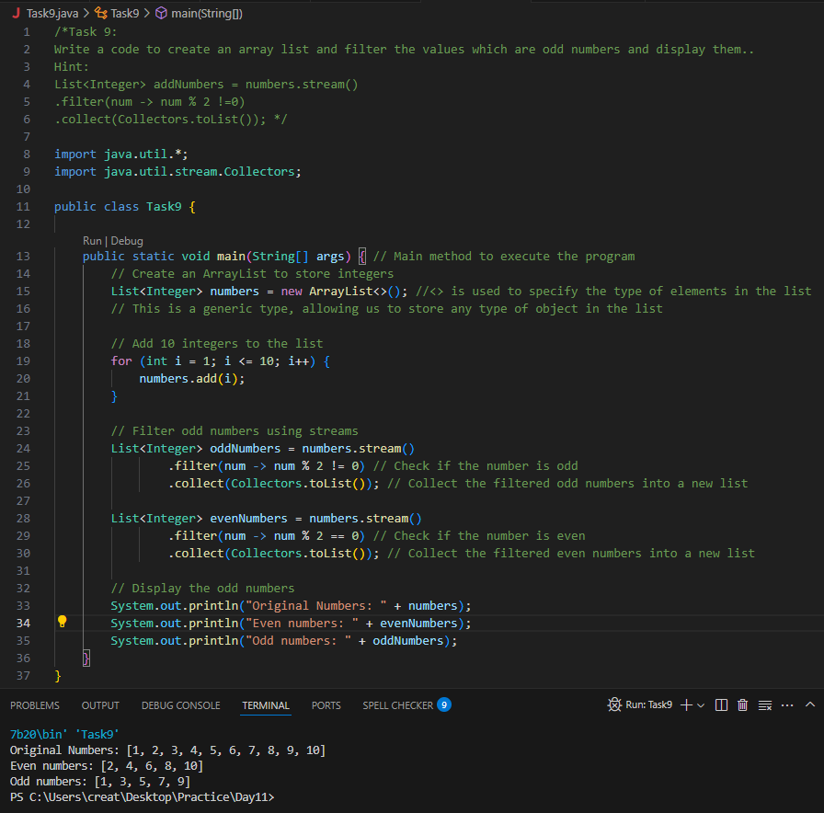
Task 10:

What do you understand by filter()?

filter() is like a gatekeeper for our data stream. It looks at each item and says, “Should this stay or go?”—based on some conditions we set. Only the items that pass the test are allowed to flow through to the next step.

Task 11:
Wap to create an array list to remove duplicate values from the List.

Hint:
List<Integer> RemovDups= numbers.stream()
.distinct()
.collect(Collectors.toList());
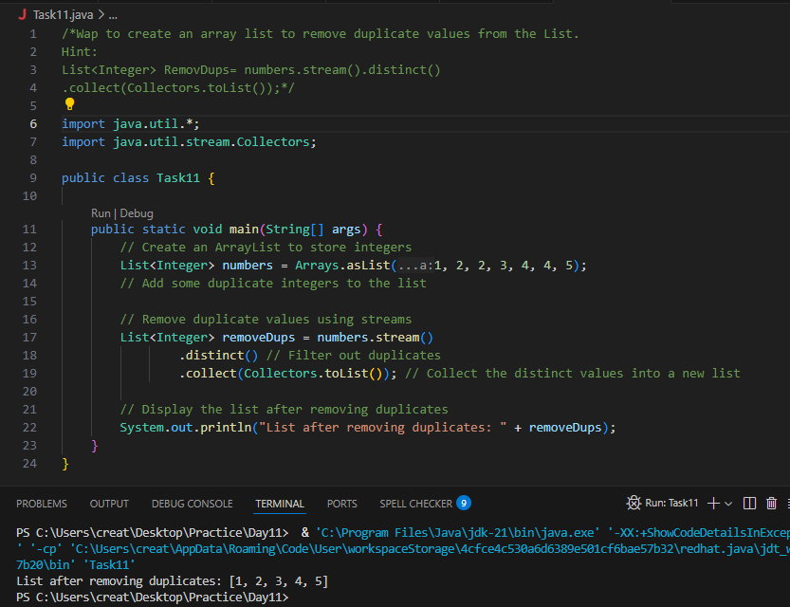

Task12:

What do you understand by distinct()?

It’s like telling our stream: “No repeats allowed.” distinct() goes through all the elements and removes duplicates, keeping only the unique ones.

Sort
Limit
Skip

Terminal op
Foreach
Collect
redure
Task 13:
Wap to create an arrayList of your friends using string and try to sort them and display

Hint:
List<String> SortedNames= Names.stream()
.sorted()
.collect(Collectors.toList());
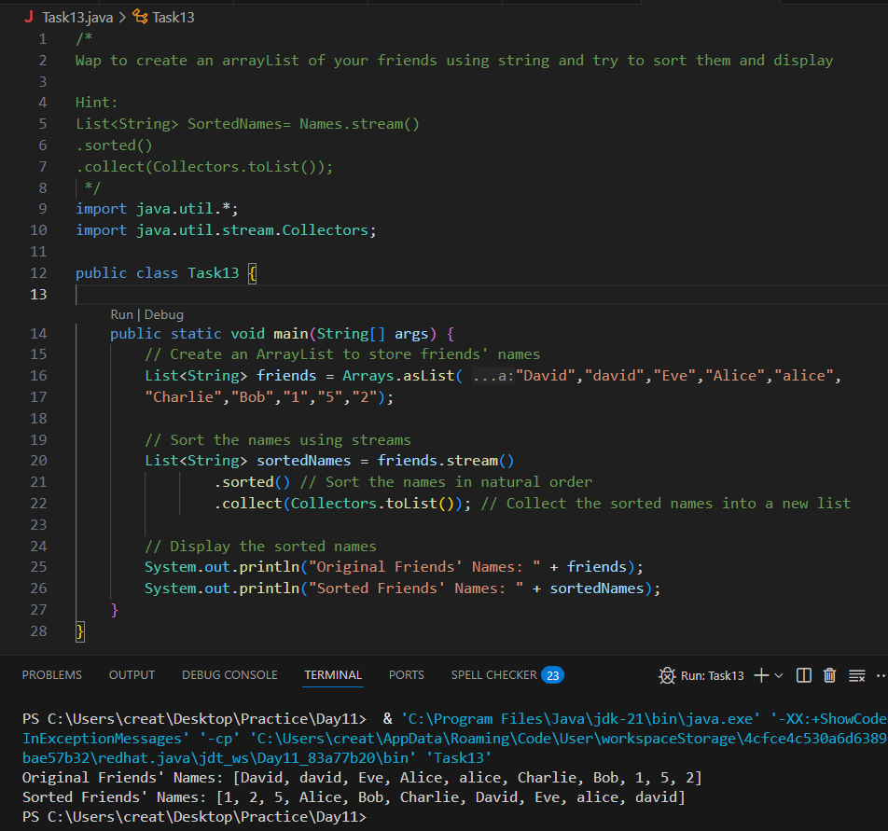
Task 14:

Wap to run a loop / iterate() and limit it to 20 values (1 to 2)
While displaying use for each to limit till 10 numbers.
Hint:
Stream<Integers> nums = Stream
.iterate(1, n -> n+1)
.limit(20);
Nums
.limit(10)
.foreach(System.out::println);
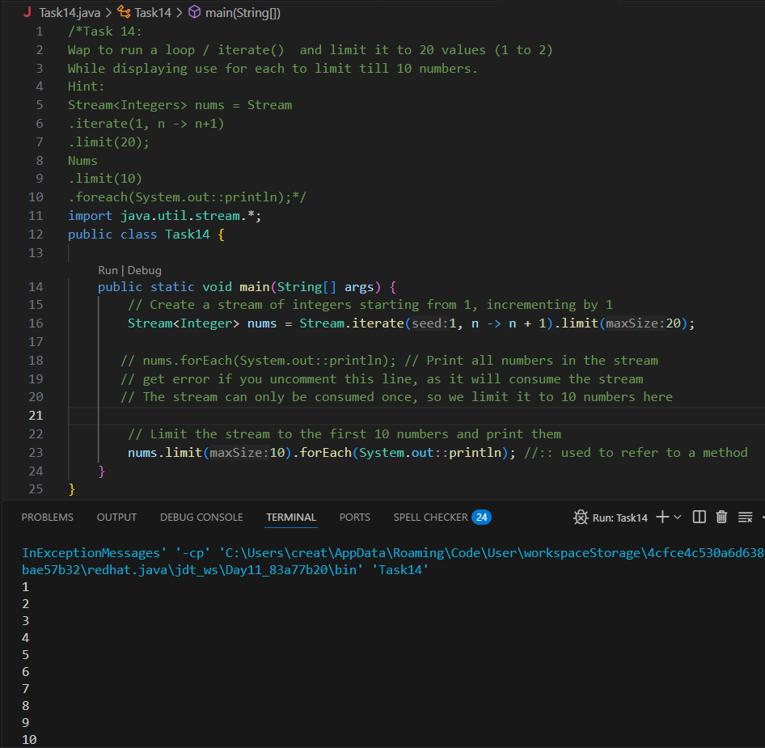

Task 15: (similar to Task 14)
Wap to create an array List skip 15 numbers and print the output using foreach loop
HInt:
Stream<Integers> nums = Stream
.iterate(1, n -> n+1)
.limit(20);
Stream<Integer> SkipNums = nums.skip(15);
Nums.foreach(System.out::println);

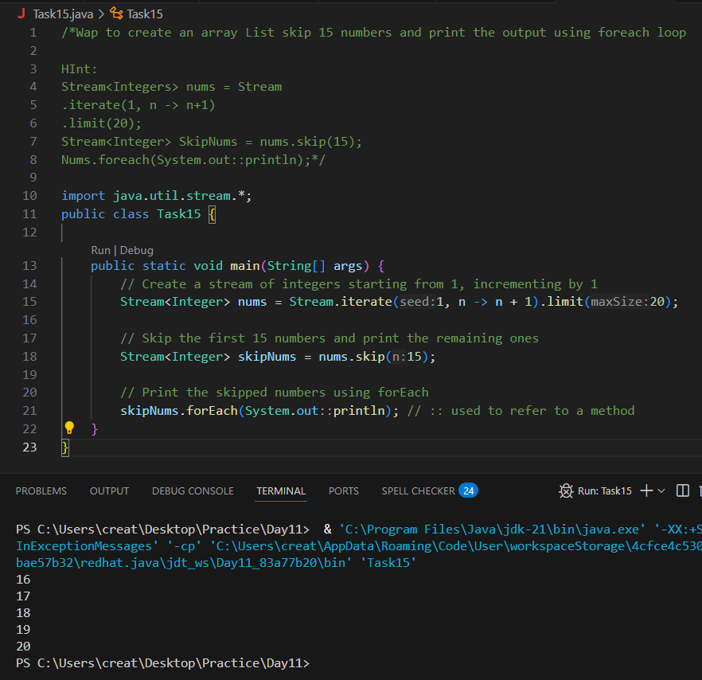

Task 16:

Explain limit and skip methods..
The limit(n) method is used to take only the first n elements from a stream. For example, if a stream has 10 numbers and you apply limit(5), it will return just the first five numbers.
The skip(n) method is used to ignore the first n elements and process the rest. So, if you have 10 numbers and use skip(5), you’ll get the last five.

Terminal operators:

Collect 👍

Done in all the above tasks to display the output of intermediate Tasks

For each 👍

You guys are familiar with for each…

Task 17:

What is the difference between mutable and immutable?
Mutable ⇒ changeable
Int

Collect ()

Immutable ⇒ cannot be changed
Wrapper classes– Integer, Long ,

reduce()

import java.util.Arrays;
import java.util.List;
import java.util.Optional;

public class ReduceExample {
public static void main(String[] args) {

List<Integer> numbers = Arrays.asList(1, 2, 3, 4, 5);

Optional<Integer> sum = numbers.stream().reduce((x, y) -> x + y);
System.out.println("Sum of all elements: " + sum.orElse(0));

Optional<Integer> max = numbers.stream().reduce(Integer::max);
System.out.println("Maximum element: " + max.orElse(0));

List<String> strings = Arrays.asList("Hello", " ", "world", "!");
Optional<String> concatenatedString = strings.stream().reduce((x, y) -> x + y);
System.out.println("Concatenated string: " + concatenatedString.orElse(""));
}
}

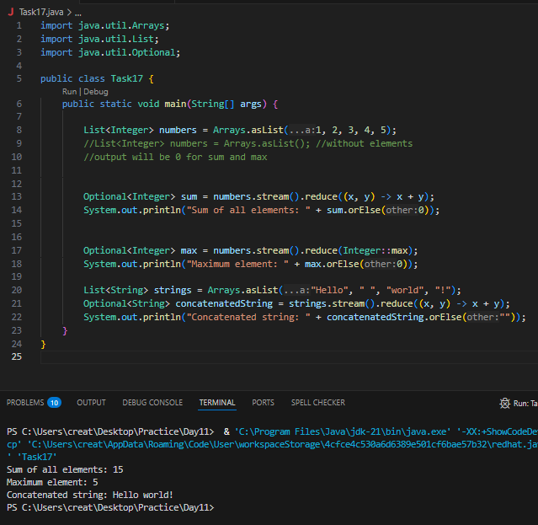

When to use reduce and when to use collect..

Reduce will be used if you are expecting a single result from the stream (eg min, max , sum, product…)

Collect will be used if you are excepting a list of values… (list, set, map)

Advantages of Streams:
Less Code, More Work I can do complex things (like filtering, sorting, mapping) in just a few lines instead of writing full loops.
Easy to Read The code looks cleaner and feels like reading steps — like a list of tasks to do on the data.
No Need to Store Temporary Data I don’t need to create extra variables or lists while transforming data. Streams handle it smoothly.
Can Work in Parallel I can make the stream run tasks in parallel using .parallelStream(), which makes it faster on big data.
Works with Collections Streams directly work on List, Set, etc. — I don’t have to convert or loop through manually.
Chaining Made Easy I can do one thing after another (like filter → sort → collect) all in a single flow.
Safe and Functional Streams don’t change the original list — they work in a safe way by returning new results.

Task 18:

What are the debugging tools in Java.. list down a few..

System.out.println()
- Basic way to print variable values and trace flow.
- Good for quick checks.
Exception Stack Trace
- Java automatically shows error messages with line numbers when exceptions occur.
- Helps locate issues in code.
JDB (Java Debugger)
- Command-line debugger that comes with JDK.
- Supports breakpoints, stepping through code, inspecting variables.
Assertions (assert keyword)
- Used to test assumptions in code during development.
- Example: assert x > 0;
Logging (java.util.logging)
- Built-in logging system in Java.
- More powerful than System.out, supports log levels (INFO, WARNING, SEVERE).

Task 19:

Error Messages in Java

Compile time and run time

Compile time : grammatical mistakes … ;, {} , missing the code

Run time error or exceptions

Stack overflow error

Array index out of bounds
IO exception

Nulpointer exception

**Compile-Time Errors**
These are syntax and structural mistakes detected *before* the code runs—during compilation.

- Missing semicolons `;`
- Mismatched brackets `{ }`, parentheses `( )`
- Misspelled keywords (e.g., `publik` instead of `public`)
- Incorrect method signatures or return types
- Type mismatches (e.g., assigning `String` to an `int`)
- Undeclared variables or missing imports
- Class or method not found

**Runtime Errors (Exceptions & Errors)**
These happen *while* the program is running—even if it compiled perfectly.

Common **Checked Exceptions** (must be handled with try-catch or throws)
- `IOException` – File not found, read/write failure
- `FileNotFoundException` – Subtype of IOException
- `SQLException` – Database connectivity issues
- `ClassNotFoundException` – When a class is not found dynamically
- `InterruptedException` – Threads get interrupted
- `ParseException` – String/date parsing errors

Common **Unchecked Exceptions** (RuntimeException subtypes)
- `NullPointerException` – Accessing a `null` object
- `ArrayIndexOutOfBoundsException` – Accessing invalid array index
- `StringIndexOutOfBoundsException`
- `ArithmeticException` – e.g., divide by zero
- `NumberFormatException` – Invalid numeric conversion
- `IllegalArgumentException` – Passing invalid values to methods
- `IllegalStateException` – Object in an unexpected state
- `ClassCastException` – Invalid object casting

**Errors** (serious issues that shouldn’t be caught normally)
- `StackOverflowError` – Infinite recursion
- `OutOfMemoryError` – Heap is full
- `VirtualMachineError` – JVM has internal issues
- `AssertionError` – Failed assertion

Task 20:

Stack trace.. What will it do?

Identify the error
Locate the code
Analyze the code
Solution also

import org.apache.logging.log4j.LogManager;
import org.apache.logging.log4j.Logger;

public class Example {
private static final Logger logger = LogManager.getLogger(Example.class);

public static void main(String[] args) {
int x = 5;
int y = 7;
int sum = x + y;
logger.debug("x = " + x);
logger.debug("y = " + y);
logger.debug("sum = " + sum);
}
}

